Maven的常用命令

Maven库：http://repo2.maven.org/maven2/

Maven依赖查询：<http://mvnrepository.com/>

# Maven创建工程项目Project

## 废弃的mvn archetype:create命令

之前利用mvn archetype:create 命令创建项目，但是现在已经过期了Deprecated，建议使用mvn archetype:generate。

**archetype** 英 [ˈɑ:kitaɪp] 美 [ˈɑrkɪˌtaɪp] n.**原型;典型**

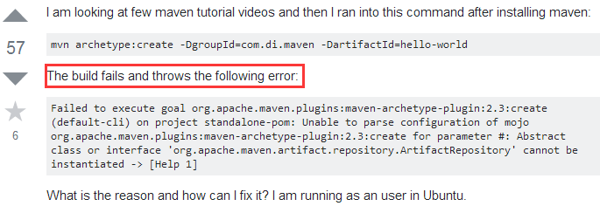

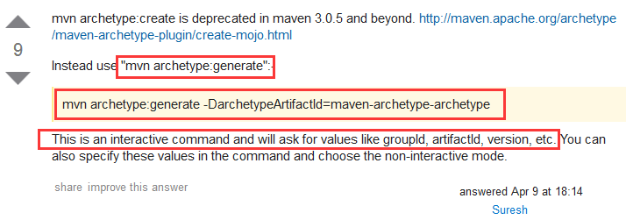

官网对archetype:create命令的介绍：

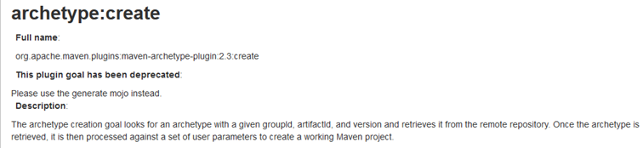

因此以后就不要再使用mvn archetype:create命令了。

## 创建工程Project的步骤Project creation

Creating a project from an archetype involves three steps:

prepare repository reference

### the selection of the archetype,原型选择

### the configuration of that archetype,原型的设置

### the effective creation of the project from the collected information

## mvn archetype:generate命令汇集

### 创建普通Java工程：

最简单的：mvn archetype:generate

指定GroupId和ArtifactId: mvn archetype:generate –DgroupId=xxx –DartifactId=xxxx

任意指定：mvn archetype:generate –DgroupId=xxx –DartifactId=xxxx –Dversion=1.0 –Dpackage=xin.zhaohong.study

**四个参数：-DgroupId、-DartifactId、-Dversion、-Dpackage指定了哪一个，在交互过程中就不再询问。**

**DarchetypeArtifactId 可以指定原型类型；**

**-DinteractiveMode=false 关闭交互模式。**

### 创建Maven的Web项目

mvn archetype:generate **-DarchetypeArtifactId=maven-archetype-webapp**

相比普通Java项目，目录发生改变，在src下为resources和webapp，webapp下有WEB-INF/web.xml。

其他四个参数同普通Java项目。

## mvn archetype:generate命令的使用

官网使用示例：<https://maven.apache.org/archetype/maven-archetype-plugin/usage.html>

### 最简单的使用方法

**mvn archetype:generate该命令是一个交互式命令，在创建过程中，首先选择一个Archetype原型，然后根据提示输入GroupId、ArtifactId、Version、Package这四项。**

**当然也可以在mvn archetype:generate后面添加默认值，在创建过程中就不再询问。**

**如：mvn archetype:generate -DgroupId=groupId -DartifactId=projectName**

**通过DgroupId指定GroupId，通过DartifactId指定ArtifactId。**



**Y作用是询问是否确定？ y表示确定，n表示重新输入。**

**In general** an archetype is coming **from a remote repository**. **If that repository can be reached via the setup of your Maven, you're ready to start.** In cases where the repository is not managed and you want to refer to it directly, you have to add the repository to your **settings.xml.** Read the small set of instructions **on the Archetype Repository-page.**

Calling **archetype:generate** the plugin will first ask to choose the archetype from the internal catalog. Just enter the number of the archetype.

It then asks you to enter the values for the **groupId**, the **artifactId** and the **version** of the project to create and the **base package** for the sources.

**四个：GroupId、ArtifactId、Version、Package**。

It then asks for **confirmation** of the configuration and performs the creation of the project.

In the following example, we selected **the quickstart archetype** (default value, which is **15** here but may vary depending on the repository content) and set groupId to **com.company**, artifactId to **project**, version to **1.0** and package to **com.company.project.**

**具体见官网示例。（已经操作，没有问题）**

**创建后的目录结构：（如果不指定package，就没有src目录，只有pom.xml文件）**

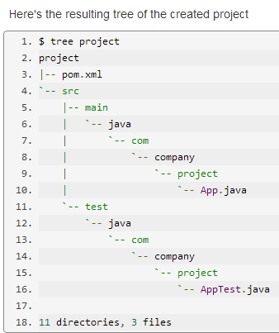

### Filtering to reduce archetype list：过滤减少原型

As of version 2.1, you can reduce the list of displayed archetypes. The filter use the following format: **[groupId:]artifactId**. If you use single word without :, only artifactId will be checked. The filtering applied is a case sensitive contains on the artifactId (and groupId if set).

Two options两种方式来过滤：

第一种：With a mojo parameter:

mvn archetype:generate **-Dfilter=org.apache:struts**

The displayed list will contain only archetypes with a groupId containing **org.apache** AND an artifactId containing **struts**

第二种：Through the prompt:通过提示输入过滤

**mvn archetype:generate**

The full list is displayed and in the prompt response, you will be able to answer with a filter.

Choose a number or apply filter (format: [groupId:]artifactId, case sensitive contains): **org.apache:struts**

Notice that if your filter doesn't match any archetype, the previous list will be displayed again.

### 减少原型种类的简单方法

mvn archetype:generate默认情况下从maven的Repository里查找所有支持的arche types,大概有500~600个。正因为是太多了，所以查找起来很是不方便。其实平时常用的arche type也就那么几个。像我会用到的：

**1.simple start**

**2. web app**

**3. Groovy basic**

很自然的就会考虑，是不是能什么简便的方法只需要从这3个组成的list里选择就可以了。 答案当然是： Yes

实现步骤如下：（本机的Maven Repository目录在C:\Users\buha\.m2 ）

1. 使用**mvn archetype:crawl 命令**，它会在 C:\Users\buha\.m2\repository目录下生成一个archetype-catalog.xml文件；

2.将**archetype-catalog.xml**移到上一层目录，也就是C:\Users\buha\.m2

3.这时再运行**mvn archetype:generate -DarchetypeCatalog=local** 就可以达到想要的目的。

(可以进一步学习archtetype-catalog.xml 的作用)。

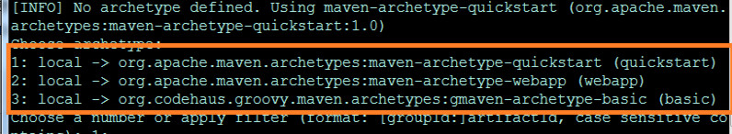

# Archetype creation创建原型

## 创建原型的步骤

Creating an archetype from an existing project involves three steps:

the archetype resolution

the archetype installation:deployment

the archetype usage

mvn archetype:create-from-project

官网介绍：<https://maven.apache.org/archetype/maven-archetype-plugin/advanced-usage.html>

Calling mvn archetype:create-from-project the plugin first resolves the package by guessing the project directory.

It then generates the directory tree of the archetype in the target/generated-sources/archetype directory.

更多的Maven命令见博客。

<https://www.cnblogs.com/wkrbky/p/6352188.html>